Insert your centre number, name and candidate number into the header above.
Save this evidence document as evidence_ followed by your centre number_ candidate number. For example: evidence_ zz999_9999
Screenshots or program listings must be copied into appropriate cells in the following table.
Examiners must be able to read the contents including any screenshots without the use of a magnifying glass. Answers that are not readable or missing will not be awarded any marks.
Save this evidence document at regular intervals, for example every 10 minutes.
Question 1
Part 1(a)
global StackData, StackPointer
StackData = [None for _ in range(10)] #array of size 10 type integer
StackPointer = 0 #type integer

Part 1(b)
def print_stack():
for i in range(10):
print(f"Data_Index {i}: {StackData[i]}")
print(f"Stack Pointer: {StackPointer}")

Part 1(c)
def Push(x: int) -> bool:
global StackData, StackPointer
if StackPointer > len(StackData) - 1:
return False
else:
StackData[StackPointer] = x
return True

Part 1(d)(i)
for i in range(11):
x = int(input("Enter an integer to push onto the stack: "))
if Push(x):
StackPointer += 1
print("Push Success")
else:
print("Stack Overflow")

print_stack()

Part 1(d)(ii)
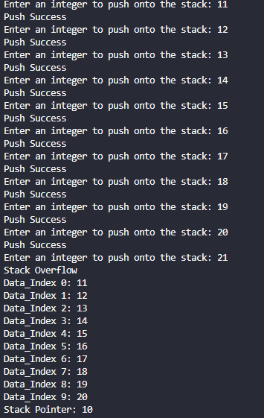

Part 1(e)(i)
def Pop() -> int:
global StackData, StackPointer
if StackPointer == 0:
return -1
else:
StackPointer -= 1
return StackData[StackPointer]

Part 1(e)(ii)
